

Linn-Benton-Lincoln Area

NEWSLETTER
Linn – Benton – Lincoln Area Narcotics Anonymous Newsletter Volume 2 Number 2—April 2005

It is once again time for another newsletter and I would like to thank all of you who sent in things to be put into it.

I would like to take this time to let everyone know that we are having a newsletter meeting on April 23, at 1:30 p.m. at my house: 725 SE Atwood in Corvallis. If you would like to have a say in what goes into your newsletter please come and give your input. You can call me at 754-7552 if you need any information or directions on how to get to my house.

“Member’s Voice” How Does My Sponsor Help Me in My Recovery
My sponsor is my life line to the program and working the steps. Without the help of my sponsor I would not have the recovery I have today!

Greetings to My Fellow Addicts,

When I first got into recovery and started going to NA meetings, I didn’t know very much about the Fellowship or the Program. I was very impatient for recovery and I thought I could cut corners, take shortcuts and work the program “my way” and become clean and serene in no time.

After a good deal of time and several failed attempts, I started, finally, to listen to the people who had been successful in the program. One of the suggestions I constantly heard was “ Get a Sponsor “!

I read the NA information pamphlet on Sponsorship and took the plunge. It was really difficult to begin to trust anyone after all my years of addiction. I learned that a person can shop around for a sponsor but I was very fortunate on my first choice.

My sponsor is someone who understands the nature of addiction. He was able to show me how I allowed my addict behavior to sabotage my recovery efforts. His patient guidance through the 12 Steps was invaluable. I was finally able to understand the steps and begin to apply them to my life. The same holds true for the traditions. He was able to help open my eyes to the concepts of a Higher Power and the nature of spirituality.

Not only has he been my sponsor but has become – and remains – a trusted and valued personal friend. We often just hang out together and enjoy life on life’s terms.

If you are new to the Fellowship of NA or are simply struggling for recovery without the help of a sponsor, I strongly urge you to find one so that they may aid you in your recovery. Living the clean life is much easier and enjoyable when you have a trusted sponsor to share your burden of recovery. I am an addict, my name is Jack V.

My sponsor means the world to me, not only is she my friend, now she is my sponsor. She is thoughtful and caring and has faith in me, even when I don’t have faith in myself.
I Love her! CA

My sponsor helps me in my recovery in a variety of ways. One such way is he has knowledge of the twelve steps since he has worked the twelve steps himself. Sponsors are necessary for one of the six suggestions listed on the back of meeting lists – Get a Sponsor – so I have one and I keep in contact with him regularly. I’ve currently worked the 5th and 6th steps with my current sponsor. He is there to listen and show me his wisdom. I thank him for his service.
Thanx Herb B.


For me my sponsor is my life line. She lives in Portland and is part of what we call a “sponsorship tree”. We are a group of women that support each other in our journey through recovery. Our tree moves up with clean time. We stretch from Oregon to Mississippi to South Africa. I have been through many sponsors and I have never felt the love and compassion that I do now from the women in our tree. We have monthly tree meetings and yearly retreats. We go to meetings and work our steps. I searched for years to fit in with people but it wasn’t until I came to NA and became part of this tree did I ever feel like I fit in. Now I know I’m home. Megan H.

My sponsor was the one person I knew I could trust. Only having to trust one person instead of a whole group made things a lot easier for me. My sponsor has been through it all with me. He calls me on my shit and worked the steps with me. My sponsor has stood up for me and will help me. He is the one I know will be honest with me no matter what as long as I am honest with him. He is the one person I can count on to not pat me on the ass or cosigning my bull shit and tells me its okay if it’s not. I still have a daily contact with my sponsor. By putting more into my recovery than all the effort I put into finding ways to get high, I put in insurance for my recovery that I won’t relapse. These are some of the things my sponsor has taught me in my eight and a half years of recovery.
LeAnna S.

My sponsor is a very important part of my life. You know some people think if they’re sponsoring you all they need to do is help you work the steps. But, my sponsor does much more than that.
She is also my friend. It doesn’t matter if it’s a good day or a bad day, I can share both with her. I think it’s important to be a friend and not just a sponsor. If you’re going to share your most shameful secrets with someone they need to be your friend also.

If I’m angry, irrational, whiny, or acting out on old behavior or character defects she’s not afraid to let me know. And she lets me know I’m not alone and that I’m still human, and I need that from time to time.

I’m very grateful for her. I believe my Higher Power put her in my life so he could speak through her. So I want to say THANK - YOU!! To my sponsor. You know who you are.
Your fellow addict, Nique D.

Fellow Addicts, My sponsor is awesome! I surely could write a book about her and our relationship. She helps me on a daily basis! A good day, a bad day, a day of awakenings, she is always there.

One of the things I love most about her is she is completely human and doesn’t try to hide behind a halo! We all make mistakes and have our character defects and issues to work on.

My sponsor is the best constant, always there for me, and always, always honest with me! I would be lost without her! Thank you Higher Power for my sponsor.
Paula D.

Hi I’m Mike, an addict in recovery, well to tell you the truth I don’t have a sponsor and the reason is my sponsor is my Higher Power. The reason is it’s the only thing working in my life. My Higher Power removed my addict ways. It’s not wise to not have a sponsor in recovery because some people need sponsors more than others.

When I started this recovery thing I wanted to stop using really bad because I had lost everything. So I made a commitment to change, I now have the will not to use. Sometimes I think about using but I think of all the hard times and the people I let down; including myself. I was one of the ones who just couldn’t put one drink down. I got drunk to get drunk and I also had to have the last smoke even down to the last breath of it.

Out of all of this I have a lot of medical problems. No matter how hard it gets just remember we don’t have to use. We can express ourselves to our sponsor or to a Higher Power.

I know this is a bit much but we need to remember what drugs and alcohol have done to our lives and to the people we love that are still out there. So remember to keep the doors open for the addict who still suffers. They did for me!

NA thank you for my recovery and the people who want recovery. Michael T.

The topic for July’s newsletter is “How Do My Sponsee’s Help Me in My Recovery.”

“Open Forum“

This section is for letters, poetry, options, and even tasteful recovery jokes. Your submissions become property of the L-B-L Newsletter. Send your submissions to L-B-L Newsletter, C/O Patti Nichols, 725 SE Atwood Ave, Corvallis, OR 97333.

I’m Your Disease

I hate meetings. I hate HIGHER POWER. I hate anyone who has a program. To all who come in contact with me, I wish you death and I wish you suffering.

Allow me to introduce myself. I am the Disease of addiction. Cunning, Baffling, Patient, and Powerful, that’s me. I have killed millions, and I am pleased. I love to catch you with the element of surprise. I love pretending I am your friend and lover. I have given you comfort, have I not? Wasn’t I there when you were lonely? When you wanted to die, didn’t you call me? I was there. I love to make you hurt. I love to make you cry. You can’t feel anything at all.. This is true glory. I will give you instant gratification and all I ask of you is long-term suffering. I’ve been there for you always. When things were going right in your life, you invited me. You said you didn’t deserve these good things; I was the only one who would agree with you. Together we were able to destroy all things good in your life.

People don’t take me seriously. They take strokes seriously, heart attacks seriously, even diabetes seriously. Fools that they are, they don’t know that without my help these things would not be made possible.

I am such a hated disease, and I do not come uninvited. You choose to have me. So many have chosen me over reality and peace.

More than you hate me; I hate all of you who have a twelve step program. Your program, your meetings, your Higher Power all weaken me and I can’t function in the manner I am accustomed to.

Now I must lie here quietly. You don’t see me, but I am growing bigger than ever. When you only exist, I may live. When you live, I only exist.
But I am here….and until we meet again, if we meet again, I wish you death and suffering.


Serenity Prayer ~ Another Look

God grant me the serenity to accept the people I
cannot change.

The Courage to change the one I can.

And the Wisdom to know it’s me.

Taken from, The Hole In the Wall Group Newsletter ~ September 2004
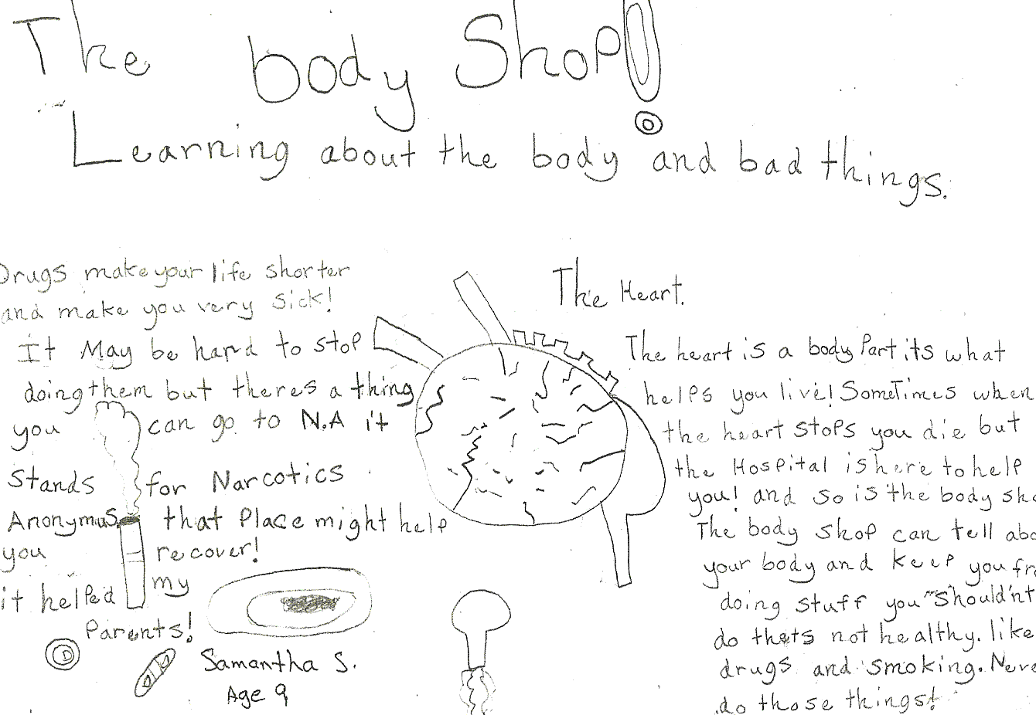

Pain

Pain in the door like a knife in the heart. She walks the streets of Manhattan, dragging her feet along. She looks down to see torn shoes with three toes sticking out of her right shoe and all five out of the left. Walking through alleys stepping on shattered beer bottles, but still she walks. Her coat drags restlessly behind her. It is soaked with alcohol, and washed with stench, soaking through her torn rags for a shirt, oh how the alcohol stings her skin. She smells like garbage, stale cigarettes, booze, sweat and blood, mixed together in one. Her pants are full of holes, stained with blood, stained with anger, stained with all the dysfunction she carries on her shoulders. So as we move from her body up to her face, as unbearable as it is, her eyes are tow deep black holes, never ending as they seem. Her lips are cracked, dry blood rests in the corner of her mouth. Her face is scarred, too painful to touch. She is skinny, too skinny. Her hands are cut, gashes here and there. She eats from the filthy ground without using her hands. She eats broken glass from the garbage.

Her mother is a heart; her father is the crack that splits down the middle of the mother. She lived in a puddle of blood growing up and things were always painful. Pain lives the color black like the ebony color of her eyes. Pain’s best friend is dream, because the only time Pain can escape is when she is with dream. Ever since Pain was little and barley developing she carried a handful of grief in one hand and her mother and father in the other. Pain lies down in a bed of hot coals next to her friend dream, to escape, to leave, to get away, but the pain is still there.

Anonymous

Apology and correction
I added something to the last page of the last newsletter hastily and without thought, and I made a mistake.
I am a firm believer in NA language, not using terms like "clean and sober" "alcoholic addict" or "drugs and alcohol", using instead terms like "drugs INCLUDING alcohol" or just "clean" I know to do so leads one to believe there are different diseases requiring two different programs of recovery and I know that to be patently untrue. Narcotics Anonymous has everything anyone would need to recover from virtually any kind of
addiction, especially those including drugs and including the drug alcohol, obsessive behavior, spiritual emptiness, and more.
The coin I put on the back picture: when I first saw it was smaller and I hastily resized it and put it on there, thinking it just to be one of our coins. After printing someone pointed out to me that it had been modified and did not use NA language. For this I apologize, as I know that to be wrong.

For something positive, an interesting metaphor came to me after two weeks where I attended only one meeting per week, NOT enough for recovery to remain stable for this addict.

My serenity happiness and recovery is a bit like tethering a blimp to the earth. I'm floating here above the ground, subject to winds of whim and circumstance. With each meeting I go to I drop one rope to the ground to hold me in place. Next day I drop another rope, and if I attend a meeting every day, with those seven ropes I am firmly grounded in my recovery, I get that partial restoral to sanity, and the winds of circumstance and daily experience don't blow me around too much. Problem is, restoral to sanity isn't a lasting condition, that is, it takes daily action. I miss a meeting and I lose a rope, miss two and I lose two. With one rope holding me like I tried in the last two weeks, I am just blown all over the place and do not intuitively handle situations. Instead I struggle and attempt control and fail at both.

I have often said I will never go a week without a meeting, and that my mind begins to smell about in the same time frame as my armpits, and my mind also needs an NA shower every day, or it starts to stink and become a dangerous thing to have directing my life. One week, one rope and I am barely here.
I like being firmly grounded in recovery, too many blessings come from that, and the balance is too delicate to take any chances with. Like it says in Just For Today - go to that extra meeting, stay on the phone that extra minute, take that extra step in trying to help a newcomer.
Let me close this with the Clarity Statement which is always printed in the World Convention Literature:
We are presented by a dilemma; when NA members identify themselves as addicts and alcoholics, or talk about “living clean and sober”; the clarity of the NA message is blurred. To speak in this manner suggests that there are 2 diseases and that one drug is somehow separate from the rest—requiring special recognition. Narcotics Anonymous makes no distinction between drugs. Our identification as ADDICTS is all inclusive, which allows us to concentrate on our similarities, not our differences.
jonathon
"Just one man beneath the sky, just ears, just eyes....."

I need to take this time to say a big I’m sorry for not getting the calendars to Area for people to put their up-coming birthdays on and send back to me. I did get a call from one of the groups in Sweet Home with birthdays but that is all I have. Once again I’m sorry.

Clean Time


April 7th Brandy B 3 years
April 23rd Brenda S 2 years
April 23rd John S 2 years
April 26th Mich 13 years

May 28th Marc 1 year

Take My Will and My Life, Guide Me in My Recovery
Show Me How to Live
CLEAN!

